1. Business Name

Electronics Shack

1. Business Address (can be fake)

1330 Rainbow Rd, 77844 College Station, TX

1. Business Phone Number (can be fake)

(979) 003-0006

1. Business Email

support@electroshack.com

1. Business Plan
   1. Business Description

We are a technology company that focuses on repair needs. We sell all types of repair products for customers to be able to repair their devices on their own. We sell parts for phones, laptops, and computers. We even sell parts to build your own computer. There are physical store locations as well as an online website.

* 1. Business Goals (list at least five goals)
* Expand our customer outreach
* Grow brand awareness
* Execute market strategies effectively
* Reach new target customers
* Develop new products to offer to customers
* Evolve our customer relations to satisfy customers and retain retention
  1. Products or Services offered

Consumer electronic parts

Consumer electronic repair tools

Consumer electronic accessories

* 1. Strategy to sell your products or service (1 paragraph)

Using various social media platforms to help reach the consumer market of the many individuals needing device repair components. The website will use effective search engine optimization to ensure we are on the first google page to reach a vast audience that searches for parts. Using facebooks extensive marketing campaign to reach many different types of potential customers. Creating tutorials to aid potential and current customers on how to properly use our products effectively. Promoting our services through banner ads from cookies collected on our website by advertising across multiple websites in the technology sector.

* 1. Market Target

Any and all who have electronic products, and need repairs.

1. About Us

Electronics Shack is a Texas consumer electronics parts and device repair supplier

* 1. List each group member

Abel Cherian, Abel Thomas, Fadil Diggs, Luke Gray, Drew Wilder

* 1. List each group member's picture

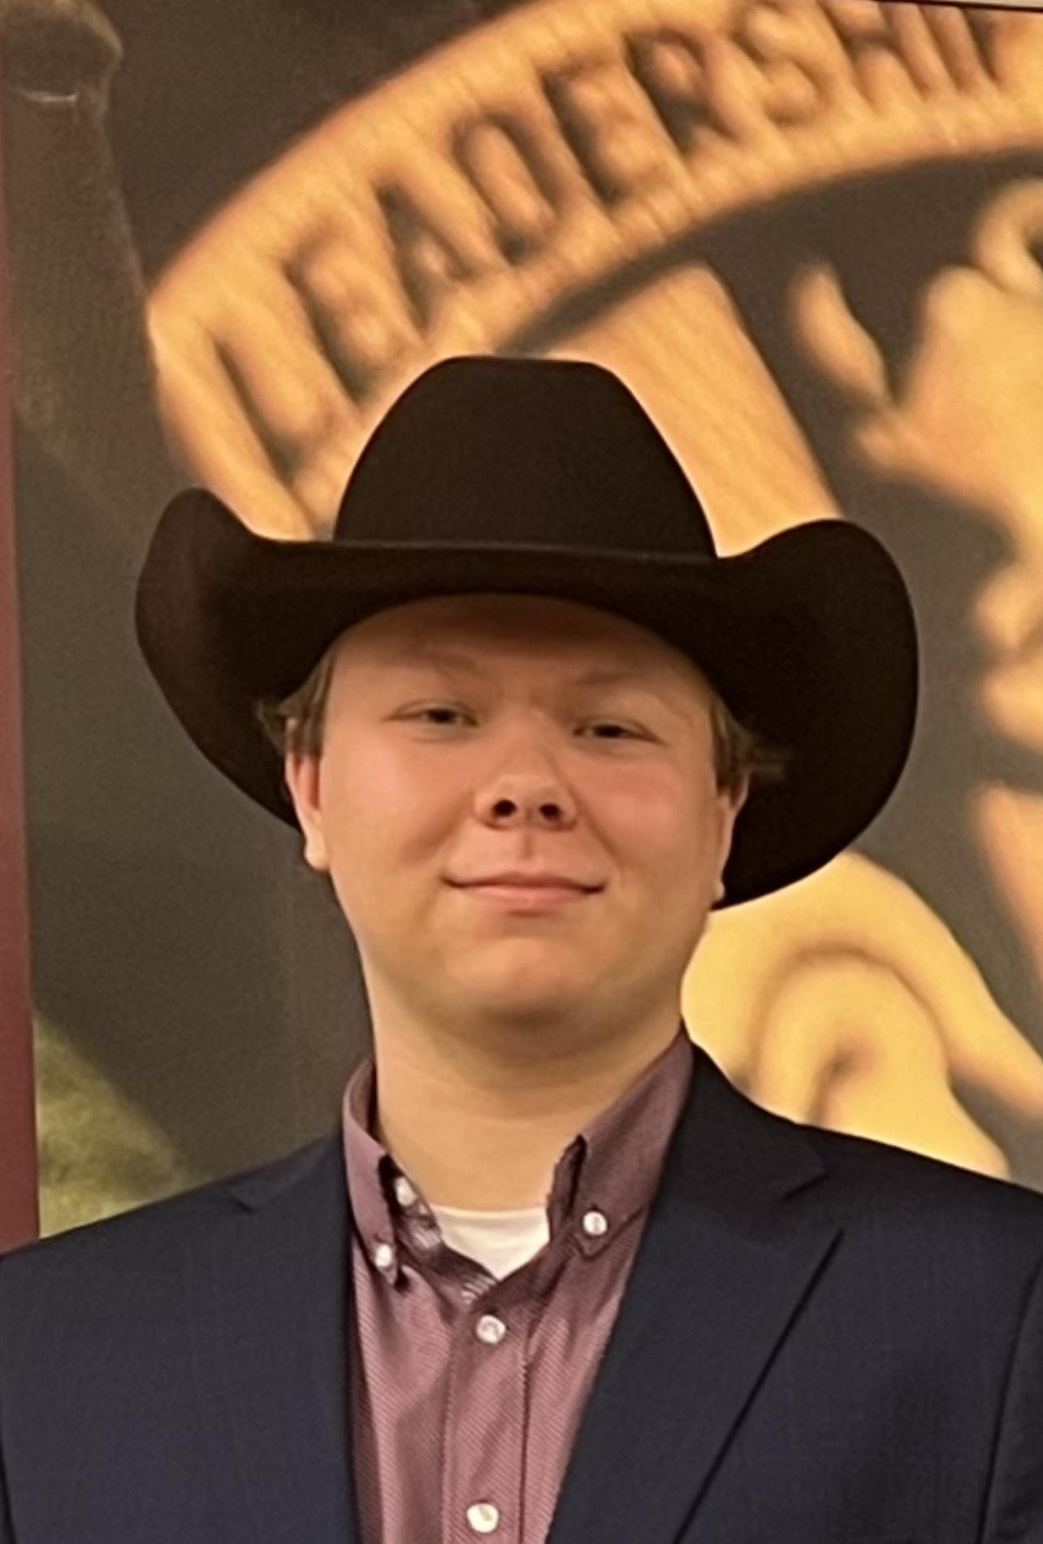 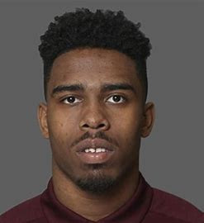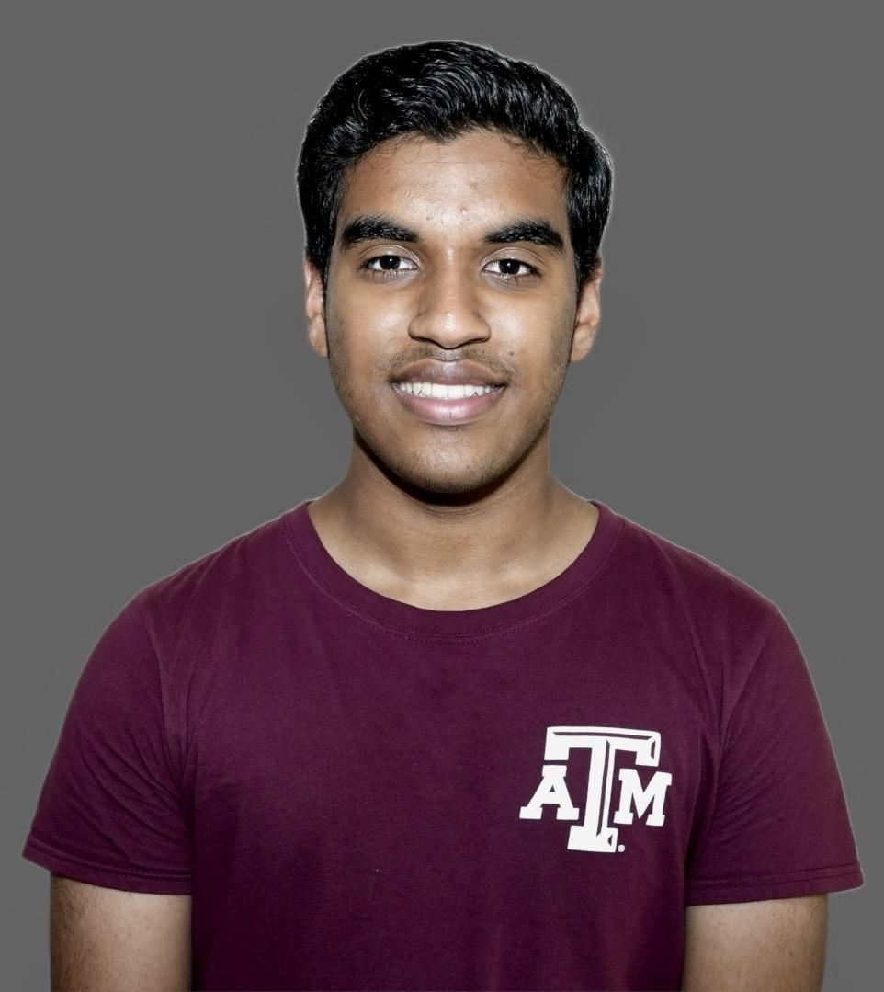



* 1. List a short bio (two to five sentences) of each group member

Abel Cherian- I am a Sophomore at Texas A&M. Majoring in Computer Engineering and minoring in math and business. I am originally from Stafford, Texas. I plan on working for a company as a software developer or as a hardware developer and making a really good salary to support my family and also enjoy.

Abel Thomas- I am a freshman Engineering Major at Texas A&M hoping to pursue Computer Science. I have also started a business minor. I am originally from Pearland, Texas. My dream is to work for the government as a part of intelligence.

Fadil Diggs- I am an RPTS major at Texas A&M and I am originally from Camde, New Jersey. I am a 3rd-year Defensive lineman for Texas A&M football. I plan to one day take my earnings from football, to create a nonprofit boys and girls club for my hometown.

Luke Gray- I am a Technology management major here at Texas A&M. I am self-employed and work for the Texas A&M AgriLife Research. For my personal employment, I build and maintain websites for businesses and restaurants and repair electronics. For Agrilife Research, I do a little bit of everything from fixing trucks, fixing tractors, fixing farm equipment, breeding seed, planting, helping other professors with their plots to plant, driving all over town to collect supplies, and doing calculations on the fields to see how much seed is needed. I plan to one day attend a T-5 Law school after I graduate.

Drew Wilder- I am a second-year Technology Management major at Texas A&M. I have just started to work with coding and computers. I was a lighting technician throughout high school and worked on hanging, focusing, and programming lights. I transferred to A&M in the fall of 2022, from the University of Oklahoma. After college, I look to work as a Project Manager.

* 1. List email address

[Lukegray@tamu.edu](mailto:Lukegray@tamu.edu)

[andrew.wilder1@yahoo.com](mailto:andrew.wilder1@yahoo.com)

[fadildiggs12@tamu.edu](mailto:fadildiggs12@tamu.edu)

[abelthom@tamu.edu](mailto:abelthom@tamu.edu)

[abelcherian66@tamu.edu](mailto:abelcherian66@tamu.edu)